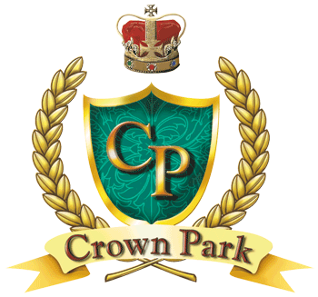
Snowbird
Memberships 2018-19
* Revised March 1, 2019
* Multi-Month Discount *
Single Couple
2 Months $625.00 $800.00
3 Months $875.00 $1125.00
4 Months $1100.00 $1425.00
5 Months $1300.00 $1700.00
6 Months $1500.00 $1950.00
*Multi-Month Discount - A surcharge of $550 will be charged for any
Couples Package that includes March, $250 for Singles.
*Multi-Month can be purchased anytime. Single Month Memberships may not be purchased until one month prior to the month being purchased.

Single Month Prices
October 2018 $375.00 $475.00
November 2018 $325.00 $375.00
December 2018 $300.00 $350.00
January 2019 $325.00 $375.00
February 2019 $375.00 $500.00
March 2019 $750.00 $1000.00
April 2019 $375.00 $500.00
May 2019 $325.00 $425.00
***Add $100 plus tax (per month preferred) to your package to get a Premium Membership
and be allowed to book starting times 5 days in advance!***

- Crown Park Golf Club Management reserves the right to adjust the above rates, at any time, due to conditions or the number of Memberships that have been purchased or are being purchased.
- No Initiation Fee.
- Unlimited golf with no green fee or cart fee. Guest, must be playing with you, $25 each.
- Juniors 16 and under free with accompanying adult.
- Daily free range token.
- Members receive a 20 % Discount in the Pro Shop and a 10% discount in the Snack Bar (excluding liquor).
- Memberships are one full month in length.
- 48 Hour booking window for March and April. We cannot guarantee any specific starting time to be available. 72 hour booking if you bring at least two paying guest.
- Membership rates do not include tax.
Please contact Crown Park Golf Club for more details (843) 756-3200
www.crownparkgolf.com

Any decisions are the sole responsibility of the Management of Crown Park Golf Club.

